**Homework 10**

**ECE 309 Fall 2019**

**Due: November 6, 2019**

Upload an electronic copy of your answers to Moodle under HW10.

*This is a shared google document. This means (1) it may change to clarify content, and (2) other people can view your comments on this file. If you have questions, you are encouraged to comment directly on this document but* ***do not add your answers here****. Make a copy into your private Google Drive and then edit the document.*

*DO NOT ADD ANSWERS TO THE SHARED DOC! THAT’S CONSIDERED CHEATING!*

# 1. Balanced Trees

1. [40 points] For the following sequences of insertions, show the BST and AVL Tree after inserting all of the nodes. For the AVL tree, keep track of each rotation that occurs and include that as a list beside the tree. For example, for (i), you might say, “after inserting 15, rotate left at 5.”
   1. 1,2,3,4,5,6
   2. 9,8,7,6,4,5,10,11,12
   3. 20,10,25,15,30,14,25,40,26
   4. 60,65,65,30,36,64,76,68,25,52
2. [20 ponts] For each AVL tree you drew in part (a), calculate the height and balance factor for each node.
3. [10 points] Consider the following AVL tree: 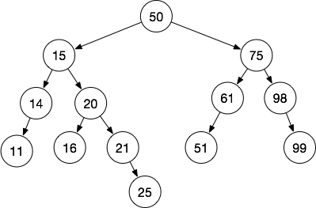

Show the tree after removing each of the following nodes (the removes compound):

* 1. 11
  2. 61
  3. 51
  4. 15

# 2. Graph Representation

[20 points] Show an adjacency list and an adjacency matrix for the following graph.

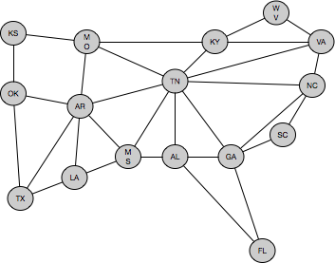

# 3. ZyLab

* [10 points] ZyLab 16.20. Implement a function to calculate the balance factor of a node in an AVL tree. The function takes a node as an argument and returns the balance factor as an integer. Read the instructions in the ZyLab for more information.

# 